Mid-Columbia Fire and Rescue
Resolution No. 2022-01

A Resolution Adopting a Supplemental Budget for FY 2021-22, Making Appropriations, and Authorizing Expenditures from and within the General Fund of the Mid-Columbia Fire and Rescue Adopted Budget

WHEREAS, the FY 2021-22 Budget of Mid-Columbia Fire and Rescue (hereinafter referred to as “District) adopted by the District incorporates operational funding for the current fiscal year; and

WHEREAS, the District’s General Fund has realized an additional $446,861.00 in unanticipated revenue, with $153,021.00 to be allocated to provide funds for a new Single Role Wildland FF program; provide additional funds to supplement unanticipated EMS training program activities; provide additional funds to supplement unanticipated EMS Equipment Maintenance activities; provide additional funds to supplement unanticipated Ambulance Billing Expense activities; and provide additional funds to supplement unanticipated Health Insurance – Admin., Ambulance Overtime and Ambulance Standby costs; and

WHEREAS, the availability of these funds could not reasonably be foreseen upon preparing the original budget; and

WHEREAS, appropriations were not made in the FY 2021-22 Budget of the District for expenditures that will be needed for the current fiscal year; and

WHEREAS, the Board of Directors of Mid-Columbia Fire and Rescue find it reasonable and prudent to adopt this supplemental budget.
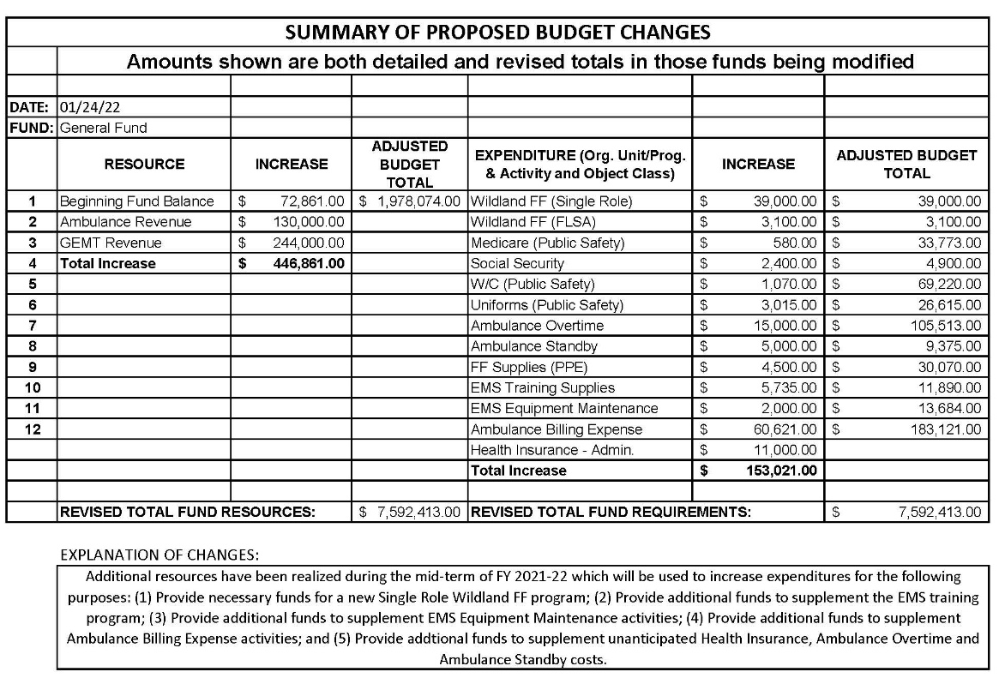

NOW THEREFORE, BE IT RESOLVED, by the Mid-Columbia Board of Directors as follows:

Section 1. The District hereby adopts the Supplemental Budget for FY 2021-22, increasing revenues and making appropriations as follows:
- That the FY 2021-22 General Fund Revenue is increased by the amount of $446,841.00, increasing total General Fund resources to $7,592,413.00.

- That the FY 2021-22 General Fund appropriation for Single Role Wildland FF line 6405-03 is hereby allocated in the amount of $39,000.00.

- That the FY 2021-22 General Fund appropriation for line 6407-00 Uniforms - Public Safety is hereby increased by $3015.00 to $26,615.00.00.

- That the FY 2021-22 General Fund appropriation for line 6416-02 Ambulance Overtime is hereby increased by $15,000.00 to $105,513.00.00.

- That the FY 2021-22 General Fund appropriation for line 6416-07 Ambulance Standby is hereby increased by $5,000.00 to $9,375.00.

- That the FY 2021-22 General Fund appropriation for line 6417-01 Overtime - Single Role FLSA is hereby allocated in the amount of $3100.00.

- That the FY 2021-22 General Fund appropriation for line 6422-00 Worker’s Compensation is hereby increased by $1070.00 to $69,220.00.

- That the FY 2021-22 General Fund appropriation for line 6424-01 Health Insurance – Admin. is hereby increased by $11,000.00 to $109,568.00.

- That the FY 2021-22 General Fund appropriation for line 6430-00 Medicare – Public Safety is hereby increased by $580.00 to $33,773.00.

- That the FY 2021-22 General Fund appropriation for line 6457-04 EMS Equipment Maintenance is hereby increased by $2000.00 to $13,684.00.

- That the FY 2021-22 General Fund appropriation for line 6459-00 Ambulance Billing Expense is hereby increased by $60,621.00 to $183,121.00.

- That the FY 2021-22 General Fund appropriation for line 6477-00 EMS Training Supplies is hereby increased by $5735.00 to $11,890.00.

- That the FY 2021-22 General Fund appropriation for line 6485-01 Firefighting Supplies – PPE is hereby increased by $4500.00 to $30,070.00.

- That the FY 2021-22 General Fund appropriation for line 6531-00 Social Security is hereby increased by $2400.00 to $4900.00.

- That the FY 2021-22 General Fund ending fund balance is hereby increased by $293,840.00 to $1,359.013.00.

- That FY 2021-22 General Fund Requirements is increased by $446,841.00 to $7,592,413.00.
Section 2. This Resolution shall become effective upon adoption by the Mid-Columbia Fire and Rescue Board of Directors and shall remain in effect until receipt and acceptance of the FY 2021-22 audit report.

Approved and adopted this 24th day of January 2022, by the Board of Directors of Mid-Columbia Fire and Rescue.

Ayes: ___________

Nayes:___________

President/Board of Directors

Attest: __________________________________
Secretary/Board of Directors

Approved as to Form: ___________________________________
Attorney of Record

